Experiment – 1

QUESTION:
Create a simple cloud software application and provide it as a service using any Cloud Service Provider to demonstrate Software as a Service (SaaS).
AIM:
To develop and deploy a basic cloud-based application using Zoho Creator and deliver it as a Software as a Service (SaaS) solution.
PROCEDURE:
- Access the Zoho Creator website and log in using a valid Zoho account to enter the application development environment.
2. Create a new application by selecting the “Create from Scratch” option to customize the project structure.
3. Choose the Web Application type and provide a suitable name that reflects the purpose of the software.
4. Design a simple form by adding basic fields such as Name, Email, and Description to collect user information.
5. Save the form and enable cloud hosting so that the application becomes accessible online.
6. Generate and share the application link with users to allow access and usage through a web browser.
7. Verify that the cloud-based SaaS application has been successfully created and deployed.
·

IMPLEMENTATION:
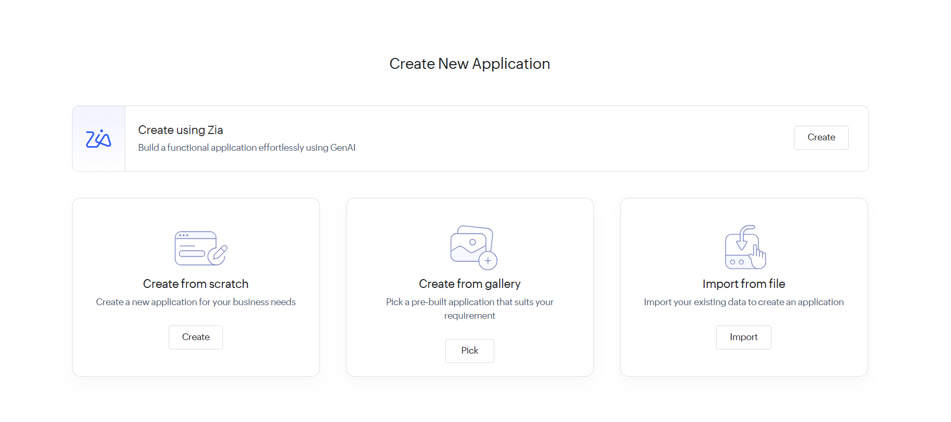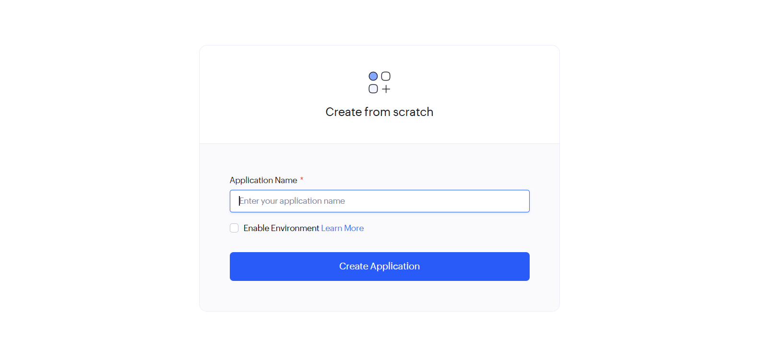
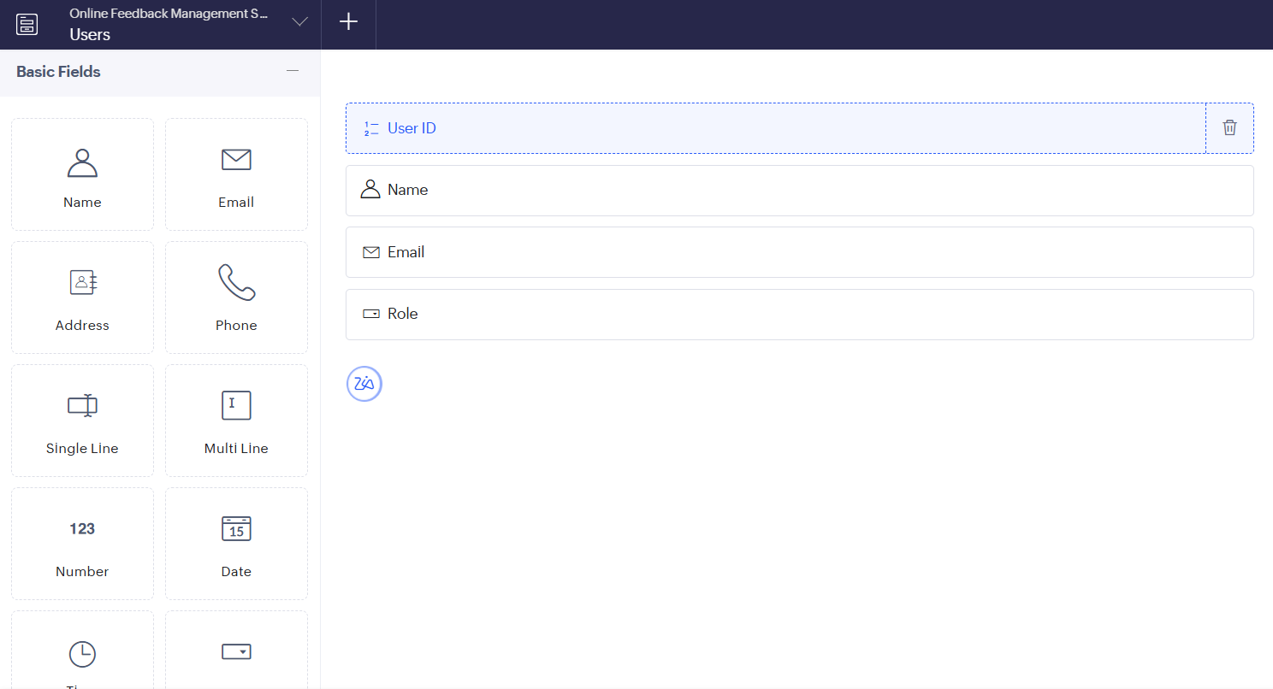
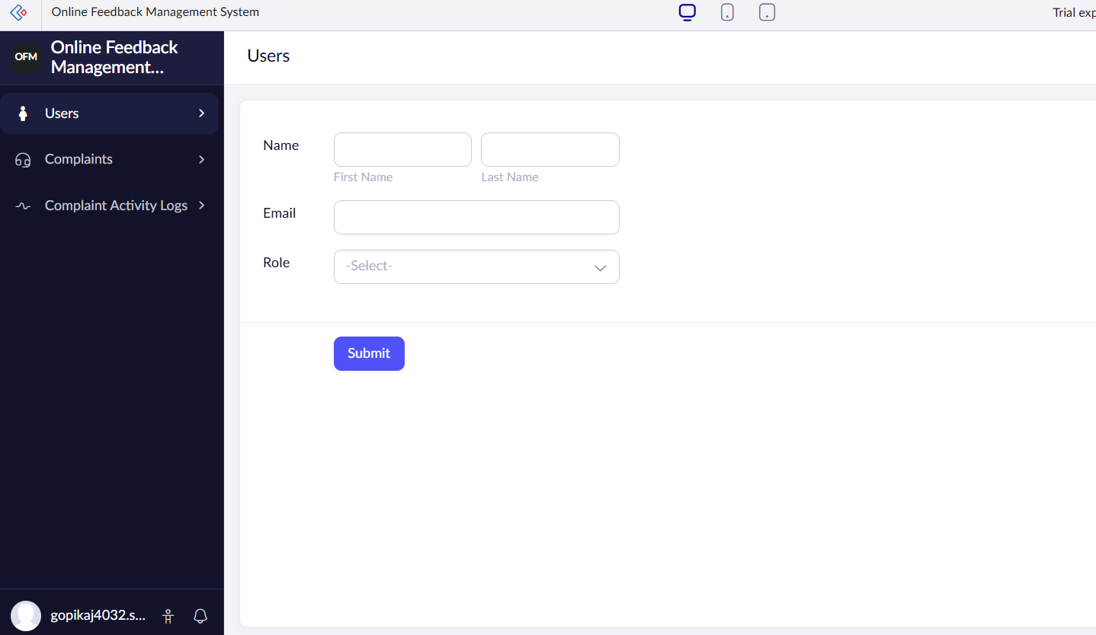

RESULT: A simple cloud-based software application is successfully created and delivered as a SaaS application, allowing users to access and use the application through the internet.

